Game Beta
Being at the Beta week, I had my nephew (hardcore gamer) try it out. He told me I had things going too slow, so I sped them up. I also added a visual to the abductions and destructions. I added some sound effects. All coming from what comes with GameMaker (not found in the “Credits” screen).

Struggles
I have a commented out section at the bottom of my levelUp() in the CameraController.js where I am attempting to add the aliengun prefab if there isn’t one. It stops the script at the point that I’m attempting to do so.
Building the project doesn’t show the “pillars” as the man is getting abducted, nor when the UFOs are destroying the house… I’m baffled. Playing the game in the editor requires you to use the spacebar or the Ctrl key to shoot as clicking around the screen starts clicking outside-of-game items (including opening programs).

Still to do
Gun pickup (needs the script to register that there isn’t one in the scene first so it can add it)
House collisions: blow up when shot 5 times and not being able to walk through them
I still need to register when the game is over with no more houses and have the Final Score screen.
A level up indicator or screen would be nice to have.
Scoring.

Game Alpha
I pretty much got the whole thing done. I have a gun for pick-up but the game acts as if you are already armed.
The controls are still the basic WASD to move and mouse to look and shoot. This game works great in its built state. Because it’s not truly in full screen in edit mode, the mouse likes to click on things outside the game.
Leveling up works! You start with 10 houses and 5 UFOs. You get bonus houses equal to your level when you level up. UFOs fly in and remove a house and leave. When all UFOs have left or are destroyed by shooting them 3 times, you advance to the next level.

Struggles
My skybox looks great other than I can see the seam. When I loaded this using DirectX, the seam wasn’t visible… I’m confused.
Is there a good way to hold the houses as I am and make them not visible? I currently set their position under the ground so you can’t see them.
My sidewalk and grass areas are slightly above the roads. I’m not worried about it so much as to the time limit but some advice of detection as to when to raise and lower the camera would be nice!

Still to do
The UFOs are going to abduct my new asset Patrick out of his house if he is there. Then the next UFO is to destroy the house. This seems easy enough, I just ran out of time this week.
Scoring. By far the best part of games and I want to give points for hitting and destroying the UFOs.
The “Credits” and “How to Play” buttons will have text in their screens instead of just the button to take you back to the menu.
I still need to register when the game is over with no more houses and have the Final Score screen.
A level up indicator or screen would be nice to have.
Since I have the alien asset and may not get to dropping them out of the UFOs, I’d like to at least place them in the UFO so you can see them in the cockpit.

New Assets
Patrick is a free download I pulled from TurboSquid. The gun is also from TurboSquid. I had fun playing with settings of the gun to make it transparent and glowing.

Game Progress Report
I have the majority of my art assets collected. I made the UFO, house, and street models using Blender. I had one of my company’s animators make me some textures for them. I grabbed an alien that I may not use for the final in this course from TurboSquid. I got the skybox from the SGPG 220 book’s CD.
I got the basic models placed and scaled into my scene and made two scripts. The first controls the camera’s movement. The other for now gives the UFOs a random destination and moves there and is given a new destination.
Arrows or mouse controls the angle of the camera while ASDW controls the movement.

Struggles
I need to figure out how to get rid of the mouse cursor and place a sprite in the center of the screen so the player knows where he/she is aiming. What I found to hide the mouse cursor didn’t work like I would want it.
I either am not fluent enough with Unity transformations or I don’t know why Unity transformations work. I’m still making my own camera movement functions.

Future
Now that the main headache stuff is out of the way (assets), I feel confident that I can get the rest of it done this up-coming week.

The Project
Aliens are invading your neighborhood in UFOs. Find a gun and fight back first person shooter style. UFOs fly in and abduct people from houses or blow them up and then leave. Once all the level’s UFOs have succeeded or are blown up, you are taken to the next level. Each new level you are rewarded with more houses and people and the number of UFOs increases as well.

Controls

Mouse
Use the mouse to control the viewing angle and to take aim.
Click to shoot.

Keyboard
Use WASD controls to move the player around the neighborhood.

Game Objects

UFOs
- Flies in from outside the neighborhood
- Moves toward a target house and hovers over it
  - Abducts the human living inside
  - Drops a bomb on a vacant house to blow it up
- Flies away
- Shot 3 times to be blown up
  - Alien is ejected out of the UFO
  - If UFO had abducted a human, it will parachute down you’ll receive a rescue bonus

Humans
- Moves into a UFO from house while being abducted
- Parachutes down from a blown up UFO
- Runs to the nearest vacant house (given a rescue bonus)
- Male, female, and children humans

Houses
- There are 55 house slots in the neighborhood
- The house either exists or doesn’t in every house slot
- Every house starts occupied
- Later levels can have more than one occupant

Aliens
- Aliens eject out of blown up UFOs
- They will run to the nearest house
  - Run away with a human
  - Suicide bomb the house
- One shot kills
- Has a gun and will shoot back
- Bigger, stronger aliens
- Smaller, faster aliens

Gun
- More of a high powered blaster
- If a second gun can be acquired it becomes a double shot blaster

Concept Art
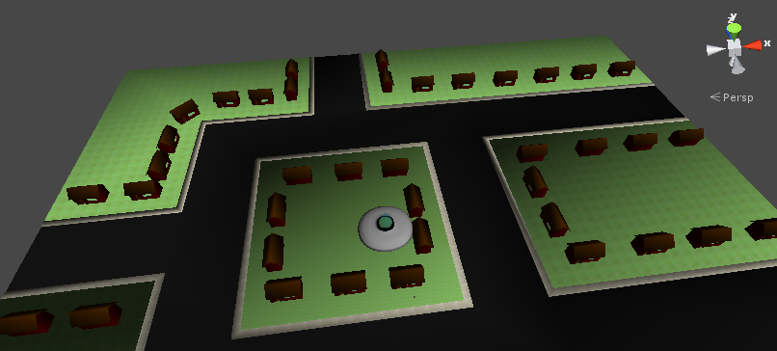

Items in red are time dependent.
Items underlined in red were trimmed from the original to help meet the time deadline.
Green items were added to compensate the removal of other items.

